1. A certain bookstore sells only paperbacks and hardbacks. Each of the 200 paperbacks in stock sells for a price between $8 and $12, and each of the 100 hardbacks in stock sells for a price between $14 and $18.

**Quantity A Quantity B**

The average price of the books in $9.99

stock at the bookstore

1. In the following figure, the circle is inscribed a square that has area 16.

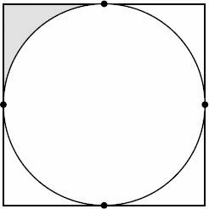

**Quantity A Quantity B**

The area of the shaded region 1

1. In triangle ABC, AB = 12, AC = 10, and BC = 5

**Quantity A Quantity B**

The measure of angle A The measure of angle C

1. If 52/x is a positive integer, how many integer values are possible for x?
2. 5
3. 6
4. 7
5. 8
6. 10
7. If $\frac{1}{n+1}<\frac{1}{31}+\frac{1}{32}+\frac{1}{33}<\frac{1}{n}$, what is the value of positive integer n?
8. If M is the sum of first 31 positive multiples of 3 and if N is the sum of first 31 positive multiples of 5, M + N is divisible by which of following?
9. 5
10. 6
11. 7
12. 8
13. 9
14. In the figure above, A is the point of tangency for two circles and also the center of the third circle. If the radii of three circles are 1, that is the external perimeter of the figure?
15. What is the domain of the function f(x) = $\sqrt{\sqrt{x-2}-\sqrt{4-x}}$
16. [-3, 4]
17. [2, 4]
18. [3, 4]
19. [-4, -3]
20. [-4, -2]
21. If all three sides of a right triangle are, respectively, radii of three semicircles, which of following statements is sufficient to determine the sum of area of three semicircles?

☐a2 + b2 + c2 = 50

☐The square of hypotenuse is 25

☐The right triangle is isosceles

1. The graph represents the normally distributed scores on a test. The shaded area represents approximately 68% of the scores

Quantity A Quantity B

The mean 550

1. The boxplot shown could be a representation of which of the following?



1. A data set with a range of 100, symmetrically distributed around its median.
2. A data set with a range of 10 and an IQR of 6.
3. A data set in which the median of the upper half of the data is closer to the lowest value in the set than to the highest value.
4. A set of consecutive integers.
5. A normal distribution.

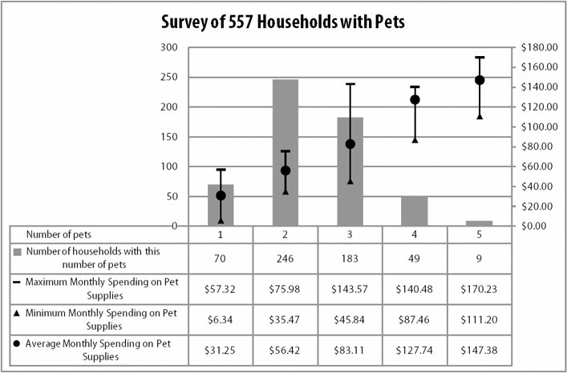

1. Approximately what percent of the surveyed households have more than three pets?
2. 10%
3. 20%
4. 30%
5. 40%
6. 50%
7. What is the median number of pets owned by the households in the survey?
8. 1
9. 2
10. 3
11. 4
12. 5
13. Grouping households by number of pets, what is the range of monthly spending on pet supplies for the group with the largest range?
14. $69.03
15. $97.73
16. $116.13
17. $138.98
18. $170.23
19. Households with how many pets have the greatest average monthly spending per pet?
20. 1
21. 2
22. 3
23. 4
24. 5
25. Quantity A Quantity B

a + d – c – 90 90 – e – b – f

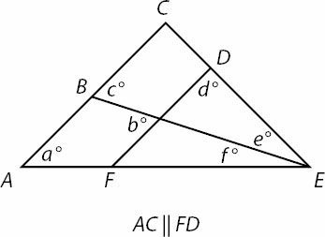

1. A man walks to his home form his current location on the rectangular grid shown. If he may choose to walk north or east at any corner, but may never moves south or west, how many different paths can the man take to get home?
2. 12
3. 24
4. 32
5. 35
6. 64

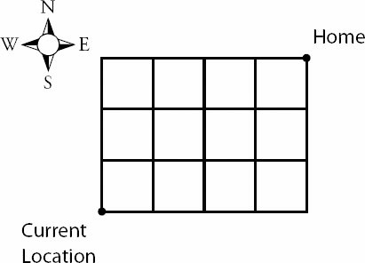

1. Each of 100 balls has an integer value from 1 to 8, inclusive, painted on the side. The number nx of balls representing integer x is given by the formula nx = 18 – (x – 4)2. The interquartile range of the 100 integers is
2. 1.5
3. 2.0
4. 2.5
5. 3.0
6. 3.5
7. When x is divided by 13 the answer is y with a remainder of 3. When x is divided by 7 the answer is z with a remainder of 3. If x, y, and z are all positive integers, what is the remainder of yz/13?
8. 0
9. 3
10. 4
11. 7
12. 10
13. In a department of biology, there are five professors and five students. If seven members of the department are randomly selected to form a committee for admission, and if the number of professors must be one more than students, how many combinations are possible?

A

B

B

B

10

D

10PI/3

C

AB

C

C

A

B

B

D

C

D

C

A

50